**CODIGO DE LA APP TAREA 3 LAS WEBVIEW**

**ERICK DAVID ROSARIO ALCANTARA CEL:402-3716804-8**

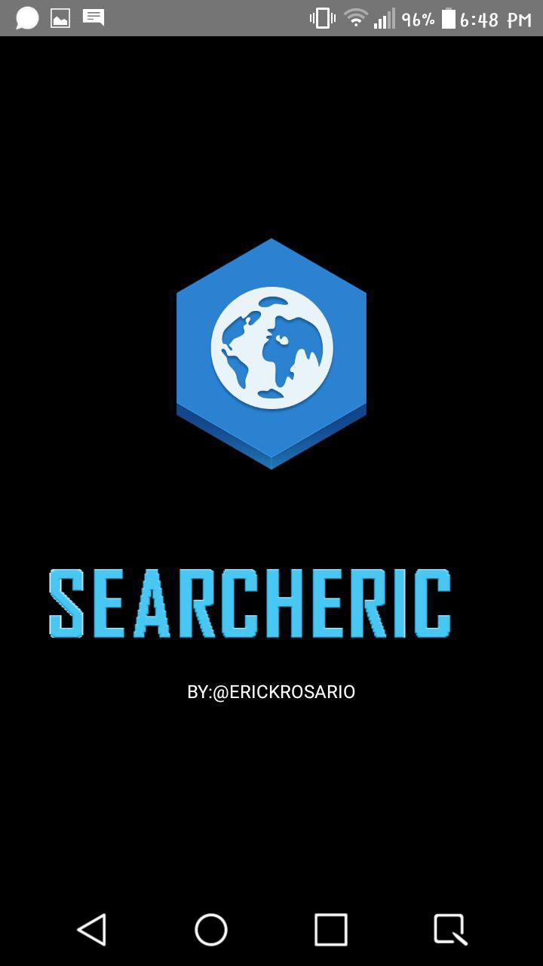

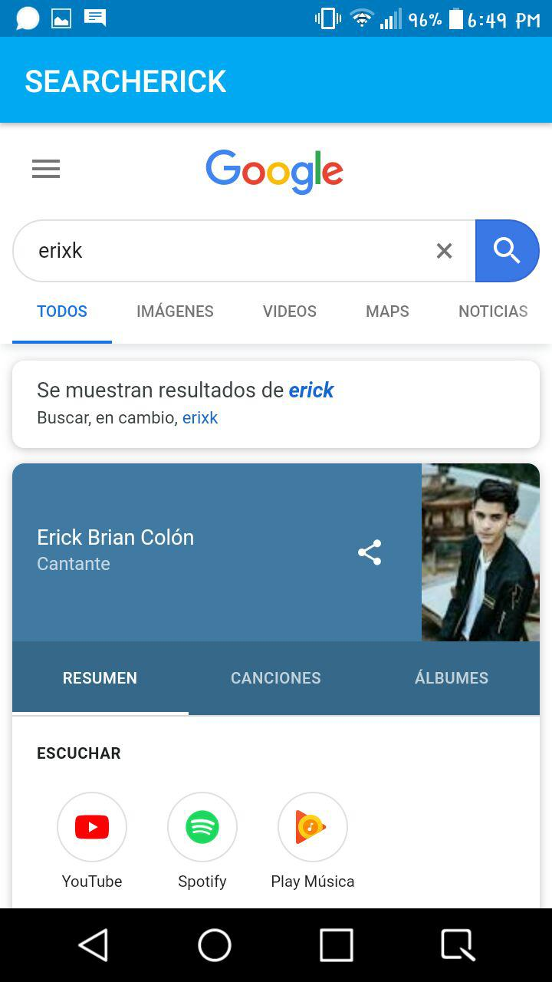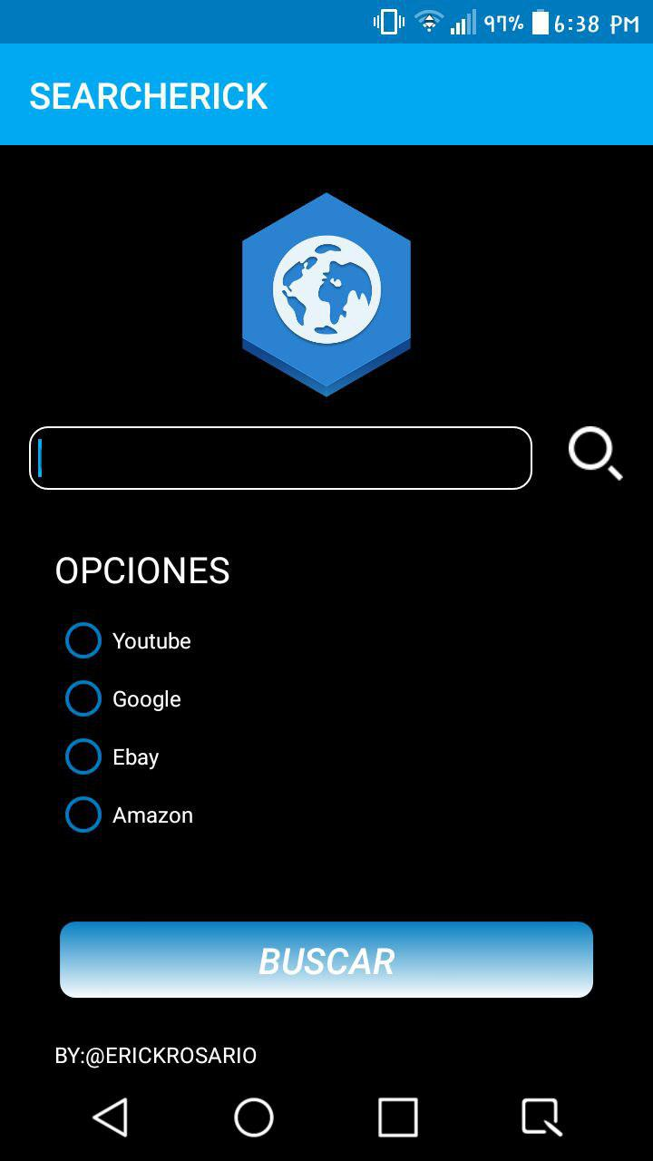

**1-CODIGO DEL MANIFEST:**

<?xml version="1.0" encoding="utf-8"?>  
<manifest xmlns:android="http://schemas.android.com/apk/res/android"  
 xmlns:tools="http://schemas.android.com/tools"  
 package="com.example.searcherick">  
  
 <uses-permission android:name="android.permission.INTERNET" />  
  
 <application  
 android:allowBackup="true"  
 android:icon="@mipmap/ic_launcher"  
 android:label="@string/app_name"  
 android:roundIcon="@mipmap/ic_launcher_round"  
 android:supportsRtl="true"  
 android:theme="@style/AppTheme"  
 tools:ignore="GoogleAppIndexingWarning">  
 <activity android:name=".SearchWebView"></activity>  
 <activity android:name=".Search2" />  
 <activity  
 android:name=".MainActivity"  
 android:theme="@style/Theme.AppCompat.Light.NoActionBar">  
 <intent-filter>  
 <action android:name="android.intent.action.MAIN" />  
  
 <category android:name="android.intent.category.LAUNCHER" />  
 </intent-filter>  
 </activity>  
 </application>  
  
</manifest>

**2-CODIGO DE LA CLASE MAINACTIVITY:**

package com.example.searcherick;  
  
import android.content.Intent;  
import android.os.Handler;  
import android.os.HandlerThread;  
import android.support.v7.app.AppCompatActivity;  
import android.os.Bundle;  
import android.view.View;  
import android.widget.ProgressBar;  
import android.widget.Toast;  
  
public class MainActivity extends AppCompatActivity {  
  
 @Override  
 protected void onCreate(Bundle savedInstanceState) {  
 super.onCreate(savedInstanceState);  
 setContentView(R.layout.*activity_main*);  
  
 new Handler().postDelayed(new Runnable() {  
 @Override  
 public void run() {  
 Intent search2 = new Intent(MainActivity.this, Search2.class);  
 startActivity(search2);  
 finish();  
 }  
 },5000);  
  
 }  
}

**3-CODIGO DE (MAINACTIVITY EN XML) ACTIVITY 1:**

<?xml version="1.0" encoding="utf-8"?>  
<LinearLayout xmlns:android="http://schemas.android.com/apk/res/android"  
 xmlns:app="http://schemas.android.com/apk/res-auto"  
 xmlns:tools="http://schemas.android.com/tools"  
 android:layout_width="match_parent"  
 android:layout_height="match_parent"  
 android:background="@color/fondonegroini"  
 android:orientation="vertical"  
 android:gravity="center_vertical"  
 tools:context=".MainActivity">  
  
 <LinearLayout  
 android:layout_height="wrap_content"  
 android:layout_width="match_parent"  
 android:gravity="center_horizontal"  
 android:orientation="vertical">  
 <ImageView  
 android:id="@+id/logo"  
 android:layout_width="170dp"  
 android:layout_height="170dp"  
 android:background="@mipmap/browser"  
 />  
  
 <pl.droidsonroids.gif.GifImageView  
 android:id="@+id/gif"  
 android:layout_width="300dp"  
 android:layout_height="100dp"  
 android:layout_marginTop="30dp"  
 android:layout_below="@+id/logo"  
 android:background="@drawable/appname"  
 />  
 </LinearLayout>  
  
 <TextView  
 android:layout_width="wrap_content"  
 android:layout_height="wrap_content"  
 android:text="@string/cello"  
 android:textColor="@color/blanco"  
 android:layout_gravity="center"  
 />  
  
  
</LinearLayout>

**4-CODIGO DE LA CLASE (SEARCH2.CLASS):**

package com.example.searcherick;  
  
import android.content.Intent;  
import android.support.v7.app.AppCompatActivity;  
import android.os.Bundle;  
import android.view.View;  
import android.widget.Button;  
import android.widget.EditText;  
import android.widget.RadioButton;  
import android.widget.Toast;  
  
public class Search2 extends AppCompatActivity {  
 private Button bttWeb;  
 private EditText bEdit;  
 private RadioButton r1,r2,r3,r4;  
 private String urlss,urls;  
 @Override  
 protected void onCreate(Bundle savedInstanceState) {  
 super.onCreate(savedInstanceState);  
 setContentView(R.layout.*activity_search2*);  
 bttWeb=(Button)findViewById(R.id.*buscar*);  
 bEdit=(EditText)findViewById(R.id.*editBuscar*);  
 r1=(RadioButton)findViewById(R.id.*radioButton*);  
 r2=(RadioButton)findViewById(R.id.*radioButton2*);  
 r3=(RadioButton)findViewById(R.id.*radioButton3*);  
 r4=(RadioButton)findViewById(R.id.*radioButton4*);  
  
 }  
  
  
 public void buscarWeb(View view)  
 {  
 urlss=bEdit.getText().toString();  
 if (r1.isChecked())  
 {  
 urls="https://www.youtube.com/results?search_query="+urlss;  
 }  
 else if(r2.isChecked())  
 {  
 urls="https://www.google.com/search?client=opera&hs=mfx&ei=WTzoXNKjHYnv_QbuoKrwCw&q="+urlss+"&oq="+urlss+"&gs_l=psy-ab.3..0i67l5j0i131j0l3j0i3.12138.14205..14380...0.0..0.168.1187.0j8......0....1..gws-wiz.....0..0i71j0i131i67.2vicu9Zgvvg";  
 }  
 else if(r3.isChecked())  
 {  
 urls="https://www.ebay.com/sch/i.html?_from=R40&_trksid=m570.l1313&_nkw="+urlss+"&_sacat=0";  
 }  
 else if(r4.isChecked())  
 {  
 urls="https://www.amazon.es/s?k="+urlss+"&__mk_es_ES=ÅMÅŽÕÑ&ref=nb_sb_noss_2";  
 }  
 else  
 {  
 Toast.*makeText*(this, "VACIO!!!", Toast.*LENGTH_SHORT*).show();  
  
 }  
  
  
 if(urlss.isEmpty())  
 {  
 Toast.*makeText*(this, "El campo de busqueda esta vacio!!", Toast.*LENGTH_SHORT*).show();  
 }  
 else if (r1.isChecked() || r2.isChecked() || r3.isChecked() || r4.isChecked() ) {  
  
 Intent webview = new Intent(this, SearchWebView.class);  
 webview.putExtra("url",urls);  
 startActivity(webview);  
 finish();  
  
 }  
 }  
  
  
  
 public void bus(View view)  
 {  
 urlss = bEdit.getText().toString();  
 if(urlss.isEmpty())  
 {  
 Toast.*makeText*(this, "El campo de busqueda esta vacio!!", Toast.*LENGTH_SHORT*).show();  
 }  
 else {  
 urls = "https://www.google.com/search?client=opera&hs=mfx&ei=WTzoXNKjHYnv_QbuoKrwCw&q=" + urlss + "&oq=" + urlss + "&gs_l=psy-ab.3..0i67l5j0i131j0l3j0i3.12138.14205..14380...0.0..0.168.1187.0j8......0....1..gws-wiz.....0..0i71j0i131i67.2vicu9Zgvvg";  
 Intent webview = new Intent(this, SearchWebView.class);  
 webview.putExtra("url", urls);  
 startActivity(webview);  
 finish();  
 }  
 }  
}

**5-CODIGO DE (SERACH2.XML) ACTIVITY 2:**

<?xml version="1.0" encoding="utf-8"?>  
<LinearLayout xmlns:android="http://schemas.android.com/apk/res/android"  
 xmlns:app="http://schemas.android.com/apk/res-auto"  
 xmlns:tools="http://schemas.android.com/tools"  
 android:layout_width="match_parent"  
 android:layout_height="match_parent"  
 android:background="@color/fondonegroini"  
 android:gravity="center_horizontal"  
 android:orientation="vertical"  
 tools:context=".Search2">  
  
  
 <ImageView  
 android:id="@+id/logo"  
 android:layout_width="125dp"  
 android:layout_height="125dp"  
 android:background="@mipmap/browser"  
 android:layout_marginTop="20dp" />  
  
 <TableLayout  
 android:layout_height="wrap_content"  
 android:layout_width="wrap_content"  
 android:layout_marginTop="10dp"  
 android:orientation="horizontal"  
 >  
  
 <TableRow>  
 <EditText  
 android:id="@+id/editBuscar"  
 android:layout_width="wrap_content"  
 android:layout_height="35dp"  
 android:hint="BUSQUEDA"  
 android:ems="15"  
 android:padding="5dip"  
 android:textColor="@color/blanco"  
 android:background="@drawable/editview"  
  
 />  
  
 <ImageView  
 android:layout_width="30dp"  
 android:layout_height="30dp"  
 android:background="@mipmap/lupa"  
 android:layout_marginLeft="20dp"  
 android:onClick="bus"  
 />  
 </TableRow>  
  
 </TableLayout>  
 <LinearLayout  
 android:layout_height="wrap_content"  
 android:layout_width="match_parent"  
 android:orientation="vertical"  
 android:layout_marginLeft="20dp"  
 android:layout_marginTop="30dp"  
 >  
 <TextView  
 android:layout_width="wrap_content"  
 android:layout_height="wrap_content"  
 android:textSize="20dp"  
 android:text="@string/opciones"  
 android:textColor="@color/blanco"  
 android:gravity="center"  
 />  
  
  
 <RadioGroup  
 android:id="@+id/radio"  
 android:layout_width="wrap_content"  
 android:layout_height="wrap_content"  
 android:layout_marginTop="10dp"  
 >  
  
 <RadioButton  
 android:id="@+id/radioButton"  
 android:layout_width="wrap_content"  
 android:layout_height="wrap_content"  
 android:checked="false"  
 android:textColor="@color/blanco"  
 android:buttonTint="@color/colorPrimaryDark"  
 android:text="Youtube" />  
  
 <RadioButton  
 android:id="@+id/radioButton2"  
 android:layout_width="wrap_content"  
 android:layout_height="wrap_content"  
 android:checked="false"  
 android:buttonTint="@color/colorPrimaryDark"  
 android:textColor="@color/blanco"  
 android:text="Google" />  
  
 <RadioButton  
 android:id="@+id/radioButton3"  
 android:layout_width="wrap_content"  
 android:layout_height="wrap_content"  
 android:checked="false"  
 android:buttonTint="@color/colorPrimaryDark"  
 android:textColor="@color/blanco"  
 android:text="Ebay" />  
 <RadioButton  
 android:id="@+id/radioButton4"  
 android:layout_width="wrap_content"  
 android:layout_height="wrap_content"  
 android:checked="false"  
 android:buttonTint="@color/colorPrimaryDark"  
 android:textColor="@color/blanco"  
 android:text="Amazon" />  
  
 </RadioGroup>  
  
 </LinearLayout>  
 <Button  
  
 android:layout_marginTop="40dp"  
 android:layout_width="300dp"  
 android:layout_height="wrap_content"  
 android:text="@string/buscar"  
 android:textSize="20dp"  
 android:textColor="@color/blanco"  
 android:textStyle="italic"  
 android:id="@+id/buscar"  
 android:onClick="buscarWeb"  
 android:background="@drawable/button_circle"/>  
  
 <LinearLayout  
 android:layout_width="match_parent"  
 android:layout_height="match_parent"  
 android:layout_marginLeft="20dp"  
 android:layout_marginTop="20dp">  
 <TextView  
 android:layout_width="wrap_content"  
 android:layout_height="wrap_content"  
 android:text="@string/cello"  
 android:textColor="@color/blanco"  
 />  
 </LinearLayout>  
  
  
  
</LinearLayout>

**6-CODIGO DE LA CLASE (SearchWebView.class):**

package com.example.searcherick;  
  
import android.content.Intent;  
import android.support.v7.app.AppCompatActivity;  
import android.os.Bundle;  
import android.webkit.WebSettings;  
import android.webkit.WebView;  
import android.webkit.WebViewClient;  
  
public class SearchWebView extends AppCompatActivity {  
 private WebView vWeb;  
 private String urls;  
 @Override  
 protected void onCreate(Bundle savedInstanceState) {  
 super.onCreate(savedInstanceState);  
 setContentView(R.layout.*activity_search_web_view*);  
 Intent recibir = getIntent();  
 urls=recibir.getExtras().getString("url");  
 vWeb=(WebView)findViewById(R.id.*WebView*);  
 vWeb.setWebViewClient(new WebViewClient());  
 vWeb.loadUrl(urls);  
 WebSettings webConfi=vWeb.getSettings();  
 webConfi.setJavaScriptEnabled(true);  
 }  
  
  
 @Override  
 public void onBackPressed() {  
 if (vWeb.canGoBack())  
 {  
 vWeb.goBack();  
 }  
 else  
 {  
 Intent search2 = new Intent(this, Search2.class);  
 startActivity(search2);  
 finish();  
 super.onBackPressed();  
 }  
 }  
}

**7-CODIGO DE (SearchWebView.XML) ACTIVITY 3:**

<?xml version="1.0" encoding="utf-8"?>  
<LinearLayout xmlns:android="http://schemas.android.com/apk/res/android"  
 xmlns:app="http://schemas.android.com/apk/res-auto"  
 xmlns:tools="http://schemas.android.com/tools"  
 android:layout_width="match_parent"  
 android:layout_height="match_parent"  
 android:orientation="vertical"  
 android:background="@color/fondonegroini"  
 tools:context=".SearchWebView">  
  
 <WebView  
 android:id="@+id/WebView"  
 android:layout_height="match_parent"  
 android:layout_width="match_parent"  
 />  
  
</LinearLayout>

**8-CODIGO DE COLORES (color.xml):**

<?xml version="1.0" encoding="utf-8"?>  
<resources>  
 <color name="colorPrimary">#03a9f4</color>  
 <color name="colorPrimaryDark">#007ac1</color>  
 <color name="colorAccent">#03a9f4</color>  
 <color name="fondonegroini">#000000</color>  
 <color name="blanco">#fff </color>  
  
  
  
</resources>

**9-CODIGO DE STRING (STRING.XML):**

<resources>  
 <string name="app_name">SEARCHERICK</string>  
 <string name="cello">BY:@ERICKROSARIO</string>  
 <string name="opciones">OPCIONES</string>  
 <string name="buscar">BUSCAR</string>  
 <string name="minavegador">MI NAVEGADOR</string>  
</resources>

**10-CODIGO DE LA CARPETA DRAWBLE LO ADAPTE:**

**-codigo para button de buscar:**

<?xml version="1.0" encoding="utf-8"?>  
<shape xmlns:android="http://schemas.android.com/apk/res/android"  
 android:shape="rectangle"  
 >  
 <corners android:radius="10dp" />  
 <stroke android:width="3dp" android:color="@color/fondonegroini" />  
 <gradient android:angle="-90" android:startColor="@color/colorPrimaryDark" android:endColor="@color/blanco" />  
</shape>

**-Codigo para bordes:**

<?xml version="1.0" encoding="utf-8"?>  
<shape xmlns:android="http://schemas.android.com/apk/res/android"  
 android:shape="ring"  
 android:innerRadiusRatio="2.5"  
 android:thickness="4dp"  
 android:useLevel="true"  
 >  
  
 <solid android:color="@color/colorPrimary"/>  
  
</shape>

**-codigo para la forma del edtiview**

<?xml version="1.0" encoding="utf-8"?>  
<shape xmlns:android="http://schemas.android.com/apk/res/android" android:shape="rectangle" android:padding="10dp">  
 <solid android:color="@color/fondonegroini"/>  
 <corners  
 android:bottomRightRadius="10dp"  
 android:bottomLeftRadius="10dp"  
 android:topLeftRadius="10dp"  
 android:topRightRadius="10dp"/>  
 <stroke android:color="@color/blanco" android:width="1dp" />  
  
</shape>